Practical 4: Singly Linked List: Dynamic Insertion, Deletion, and Traversal
Practical Aim
To implement core singly linked list operations and develop the ability to manipulate dynamic sequences through real-world problem scenarios.
Problem 1
Problem Statement
A hospital manages a queue of patient tokens. New critical patients must be added to the front, routine patients are added to the end, and occasionally a patient with a priority number must be inserted at a specific position in the queue. Given a sequence of such operations, implement all three insertion types and print the final queue after each operation.
Describe how your insertion at a specific position works. What does your solution do if the position given is greater than the current length of the queue? Is that handled explicitly or does it cause an error?
Code
https://github.com/AD-9218/DATA-STRUCUTURE-AND-ALGORITHM/blob/main/practical-4/4_1.c
Output
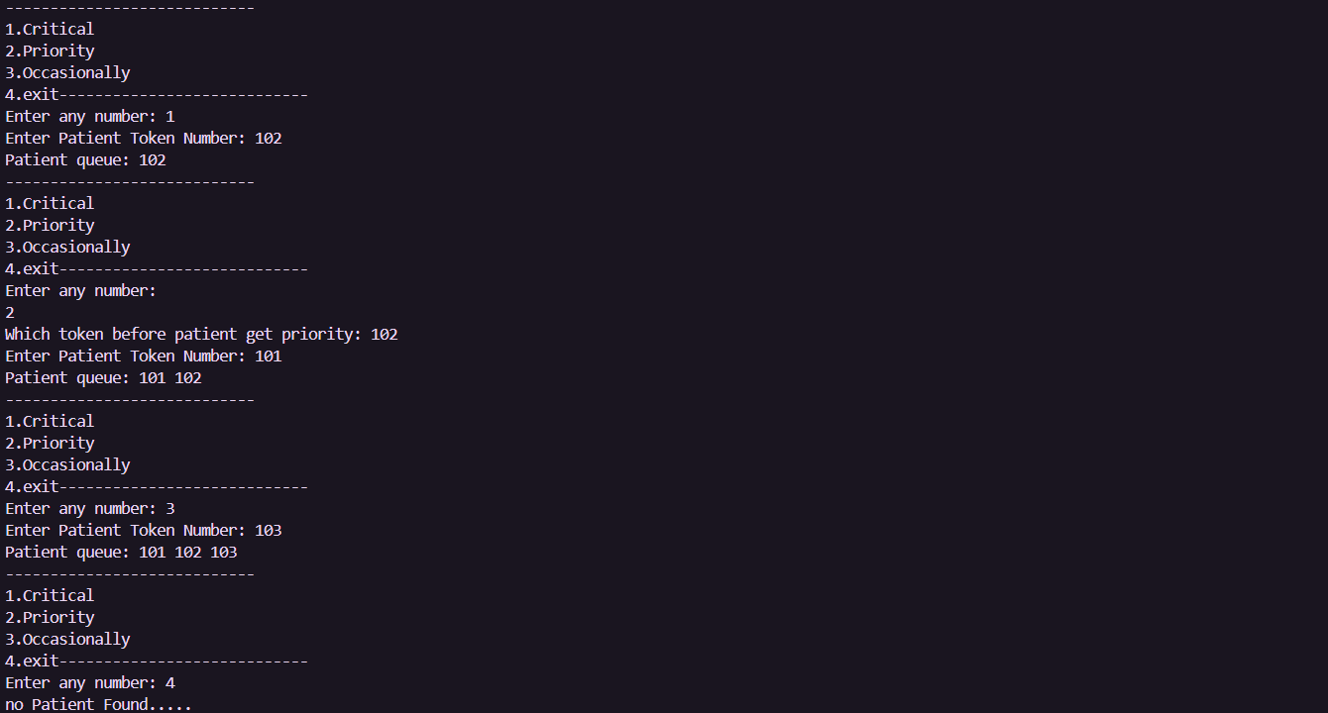

Problem 2
Problem Statement
The hospital also needs to remove a patient token from the queue when a patient leaves, print all remaining tokens from last to first for an end-of-day audit, and display the full queue from front to back at any point. Implement deletion by value, reverse printing, and forward traversal on the same queue from Problem 4.1a.
Describe how your reverse printing works. Does it use any extra storage, or does it work purely by following the links? Can you think of another way to reverse-print without modifying the original queue?
Code
https://github.com/AD-9218/DATA-STRUCUTURE-AND-ALGORITHM/blob/main/practical-4/4_2.c
Output
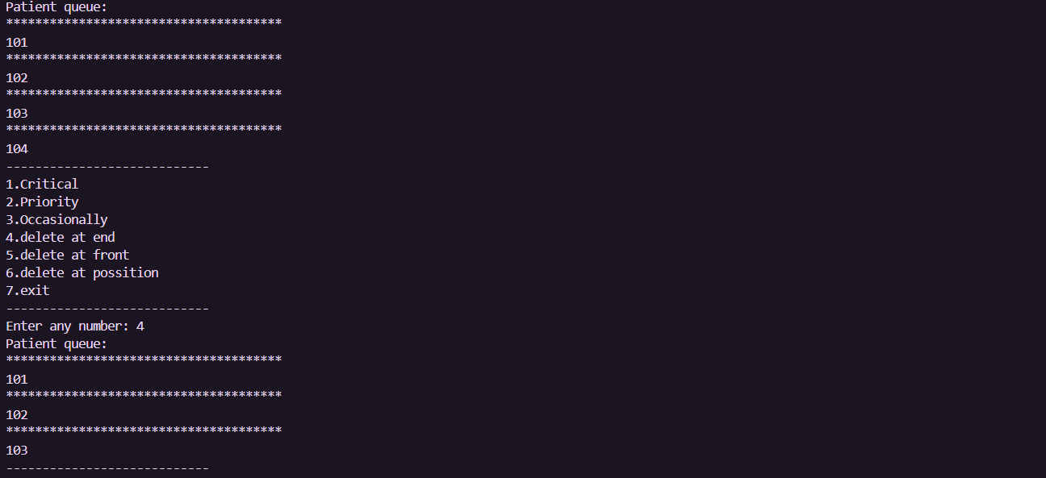
Key Questions / Analysis / Interpretation to be Evaluated During/After Implementation
1. [Problem 1] Inserting at a position beyond the current length of the list is an invalid
operation. Should your solution silently insert at the end, report an error, or do something
else entirely? Justify your choice and explain what assumption about the caller your
choice makes.
Answer: It should report an error because the position is invalid. This assumes the caller gives a valid position within the current list length.

2. [Problem 2] If the node to be deleted is the only node in the list, how many pointers need
to change and what must they be set to? How is this case structurally different from
deleting a node in the middle?
Answer: Only the head pointer needs to change, and it should be set to NULL. In the middle, the previous and next nodes must be connected to each other.
Conclusion:
We learned how to insert and delete nodes in a linked list.
We understood how to handle valid and invalid positions.
We also learned to handle deletion of the only node.
These operations helped us understand linked list structure and pointers.
Overall, we improved our understanding of linked list implementation.

